**CSCE 5430 SECTION 009 – SOFTWARE ENGINEERING**

**DELIVERABLE -5**

**PROJECT NAME : ANDROID WOMEN SAFETY APP**

**TEAM NAME :**

**SOFTWAREENGINEERING_PROJECT**

**TEAM MEMBERS:**

Krishna Sai Ujwal Kambhpati

Vineesha Sangepu

Sharan kumar Pallapu

Praveen Reddy

Jayakanth Madineni

Vineela Pamarthi

Sai Tai Prathyusha

**Softwareengineering_project Project**

**Deliverable 5-Project Phase 3**

**Report Requirements for Phase3**:

The functional requirements for phase 3 are as Follows.

* The Requirements for this phase includes the Login page, Registering for the new account, sign-in page , add emergency contact information, viewing the contact details, to view the profile of user, emergency alarm, secure me, feed back, fake call, logout

The Requirements in Phase 3 are:

USER REGISTRATION

* + - When the user opens the app it shows the login activity where user can click on the create account link which opens a new account activity where the user has to give their new account details and click on register button to create an account.

LOGIN

* + - In the login activity of app the user is asked to enter password, if correct password is entered then it opens dashboard in the app.

DASHBOARD

* + - After successful login the dashboard is displayed to user where the user can add contacts, view contacts, view and update profile, send alarm sms to contact members and send location to contact members.

ADD CONTACT

* + - In this activity the user can store others contact details such as their names and mobile numbers so that sms or location can be shared at emergency.

VIEW CONTACT

* + - This activity shows all contact details. It helps the user to view whatever information they have added regarding the emergency contact.

PROFILE

* + - This activity shows profile of the user where it also allows to update the user profile. This feature enables users to look up the information that is added about the user.

EMERGENCY ALARAM

* + - When user clicks on the emergency alarm button on the dashboard it immediately sends help sms message to all contacts already added in the contacts list. This feature is useful to help the user immediately when there is an unwanted danger.

SECURE ME

* + - When user clicks on secure me button on the dashboard it immediately sends user location latitude and longitude as sms to all contacts so that the can track this user in emergency conditions. This feature allows the emergency contact to track the user’s live location to track them and be able to help the user.

FAKE CALL

* With this feature, user can give a fake call to their own mobile to protect themselves from any unwanted situation. When user clicks on this feature, a ring tone and screen pops up that helps user to pretend they are on a call.

FEEDBACK

* This feature helps user to give a feedback to the person who saved them that will motivate the registered users who helped the victim to continue their work.

LOGOUT

* With this module, user can logout of their account and secure their personal details.

**Report UML diagrams:**

**Use case Diagram:**

**Use case diagram( error case)**

**Class diagram for phase 3**

**Sequence Diagram:**

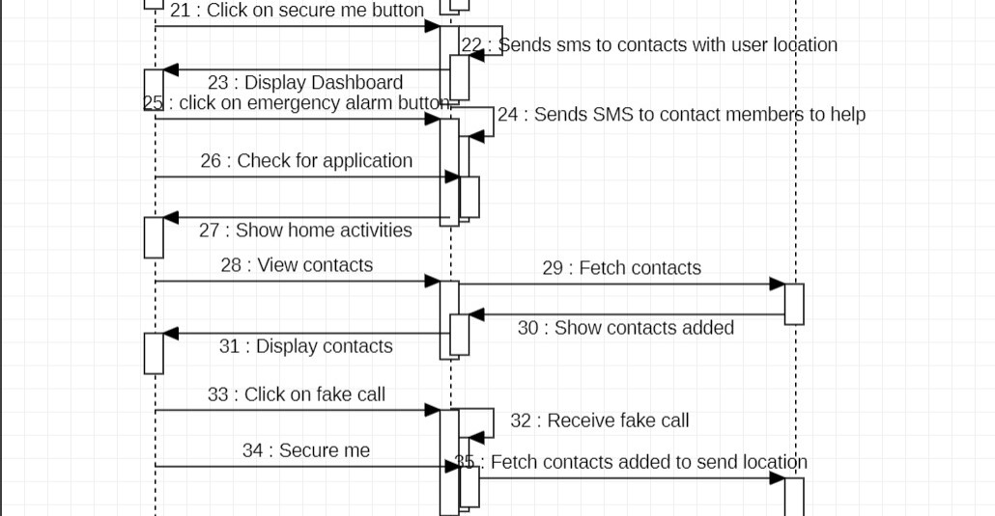

**Report Test cases:**

**Work Flow of our Requirements:**

1. When the user clicks on the women safety app it asks for login password. After giving the password it shows dashboard.
2. In the dashboard it shows various buttons such as add contact, view contact, profile, emergency alarm, secure me, logout buttons.
3. If the user clicks on add contact button it shows a form where the user can enter contact person name and phone number which stores in the database.
4. If the user clicks on the view contacts button, then it shows all contacts in list view.
5. If the user clicks on the profile button, then it shows profile in the activity and also allows to change the profile so that it updates in the database.
6. If the user clicks on the emergency button on the dashboard it sends a helpful SMS message to all contacts in the contacts’ book.
7. If the user clicks on the secure me button then the app gets the location of the user and sends location as SMS to all contacts so that they can track the user.
8. User can use feedback feature to give feedback to the person who helped the user when in need.

**Report User Manual**

A user manual describes how to install/use the application. This helps the end users of the software. Here are the steps needed to be followed to use the application.

1. First, we need to install the software in our mobile. Since we are not launching this app into any app store for now, we can directly install this app as a (.apk file).

This is the welcome page after the installation of the application is done.

1. After the installation is done the next step is the creating an account in the app by entering all the required details.

After entering all the required details, we need to choose a password and submit the user creation form and make sure that we keep the note of the password so that we can login next time without any hustles. Now the user account is created and is ready for use.

1. Once the account is created the next step is to add emergency contact details. You can add the emergency contact details like shown below. We suggest you add these details accurately and double check them.

1. Its always better to add an alternate emergency contact details because in case of emergency if one contact doesn’t respond we always have the feasibility to send the alerts to a second person.

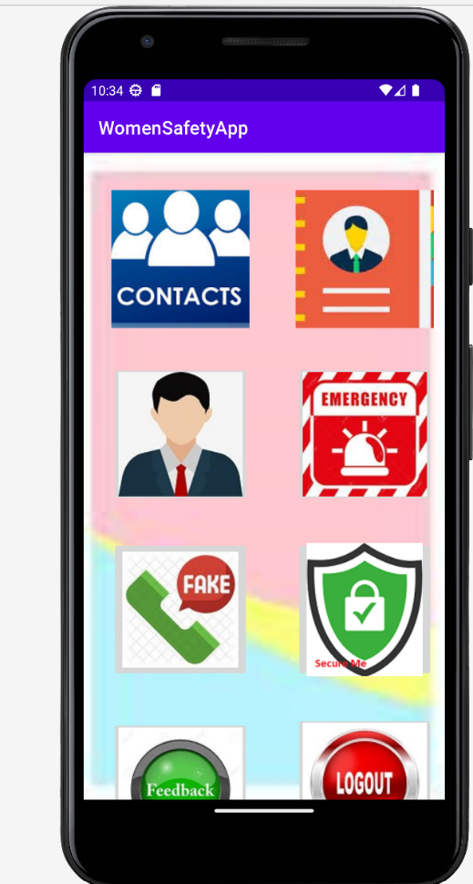

1. After adding emergency contact details, the app is almost ready to use. Once we fill all the details, we can see a dashboard displaying all the features and there is one clickable hyperlink for each feature.

These are the features available in the app.

1. CONTACTS: To add emergency contacts. We can always view and edit emergency contact details.
2. View Contacts: To view the list of emergency contacts.
3. Fake Call: This action allows user to make a fake call.
4. Securable: This actions allows to send alert to nearby users
5. Feedback: This feature allows users to give feedback to the person that has helped the user.
6. Logout: We can logout or quit from this app using this feature.
7. Emergency call: user clicks on the emergency alarm button on the dashboard it immediately sends help sms message to all contacts already added in the contacts list
8. Secure Me: This feature allows the emergency contact to track the location of the user.

Fake call feature:

**Report Compilation instructions**

Clear instructions how to compile/run both program ans your test cases

* We have to install JDK with respect to the OS platform.
* Android studio installation is required.
* Then, Open the Android Studio application.
* Select the file menu - select open – and then select path of the project path(Women Safety App) and then click on OK.
* Connect your mobile to the laptop using the USB cable.
* Select the device from the drop down menu on the toolbar
* And then click on the run app button.

**Report Ending Feature Summary:**

* In this phase, we have modified the feature feedback to send the feedback to the person who helped or saved the user.
* We have implemented almost all the features as discussed in the deliverables. We developed features like adding emergency contacts, viewing list of emergency contacts added by the user, We have created a profile section for the user to add their personal details like address, phone number, age etc.
* Also we developed an emergency button for the user to push at the time of emergency. Once the user clicks the emergency button sms will be sent to the emergency contacts added by the user. We have added an option of fake call so that the user can make fake calls at the time of emergency.
* Secure me option helps the user to send the location of the user once they clicks it to the emergency contacts.
* Feedback option helps the users to give feedback to person who helped them and finally there is a logout option once the user clicks it they will be logged out of the application.

**Report Reflection:**

• As of Phase3, we have accomplished updating the profile features like the user can change the email id, update a new phone number, update or change their password.

• A new feature of sending feedback to the person who have helped the user in the danger.

• The user can also add emergency contacts according to their choice and on pressing the emergency contacts at a time needed an emergency text like “ Help me” is sent to the emergency contacts.

• We also added the “secure me” button on pressing it all the emergency contacts the user has added in the App receive a message from the user which shows their exact location and they can use that to secure the user.

* As of the project, we have developed user registration, login, dashboard, add contact, view contact, profile, emergency alarm, secure me features which has different importance in the application.

**Member Contribution Table (For Deliverable 5):**

|  |  |  |
| --- | --- | --- |
| Member Name | Contribution Description | Overall Contribution |
| Krishna Sai Ujwal Kambhpati | Team leader, developed the contact page on the app and contributed for project ideas with the team and report reflection. | 14% |
| Vineesha Sangepu | Contributed for Report UML diagram designer. And compilation instructions for the project. Worked on secure me feature and coding the home activity page. | 14% |
| Praveen Reddy Talupu | Backend designer, zoom meeting organizer, worked on modules and functionalities of the project. | 12% |
| Vineela Pamarthi | Report UML report designer, report ending future summary. | 12% |
| Jayakanth Madineni | Logic Developer & Backend support, Contributed for the report & code requirements. | 12% |
| Sharan kumar pallapu | Server connection developer & contributed for documentation, Information provided for modules, Logout page developer, worked on gnatt chart & made final changes to the ppt. | 12% |
| Sai Tai Prathyusha Garikapati | Frontend designer, Contributed to the project ideas and implementation & Quality Analyst for the App and Core requirements, Feedback feature designer. | 12% |

Note: Referred from the previous deliverable for the previous phases, compilation instructions and the user manual.